JENKINS TASK -02

Configure 2 slave machines in Jenkins master.
Prerequisites
- Jenkins master is installed and running.
- Slave machines have Java installed and are reachable via SSH.
- You have SSH credentials (username/password or private key) for the slave machines.

1. Install Required Plugins
- Go to Manage Jenkins > Plugins.
- Ensure SSH Build Agents and Node and Label plugins are installed.

2. Create SSH Credentials
- Go to Manage Jenkins > Credentials > Global > Add Credentials.
- Choose SSH Username with private key.
- Add credentials for each slave machine.

3. Add Slave Nodes
Repeat this for each slave machine:
a. Go to Manage Jenkins > Nodes > New Node
- Name: slave-1 (or slave-2)
- Type: Permanent Agent
b. Configure Node Details
- # of Executors: 1 or more depending on CPU
- Remote root directory: /home/jenkins
- Labels: linux, build, etc. (optional)
- Usage: Use this node as much as possible
c. Launch Method
- Choose Launch agents via SSH
- Enter:
  - Host: IP or hostname of slave
  - Credentials: Select the SSH credentials you added
  - Java path: /usr/bin/java or appropriate path
d. Save and Connect
- Jenkins will try to connect and launch the agent.
- If successful, status will show as Connected.

4. Verify Connection
- Go to Manage Jenkins > Nodes
- Both slave-1 and slave-2 should show as Online

5. Test with a Job
- Create a freestyle job.
- In Restrict where this project can run, enter the label of one of the slaves.
- Run the job and verify it executes on the correct node.

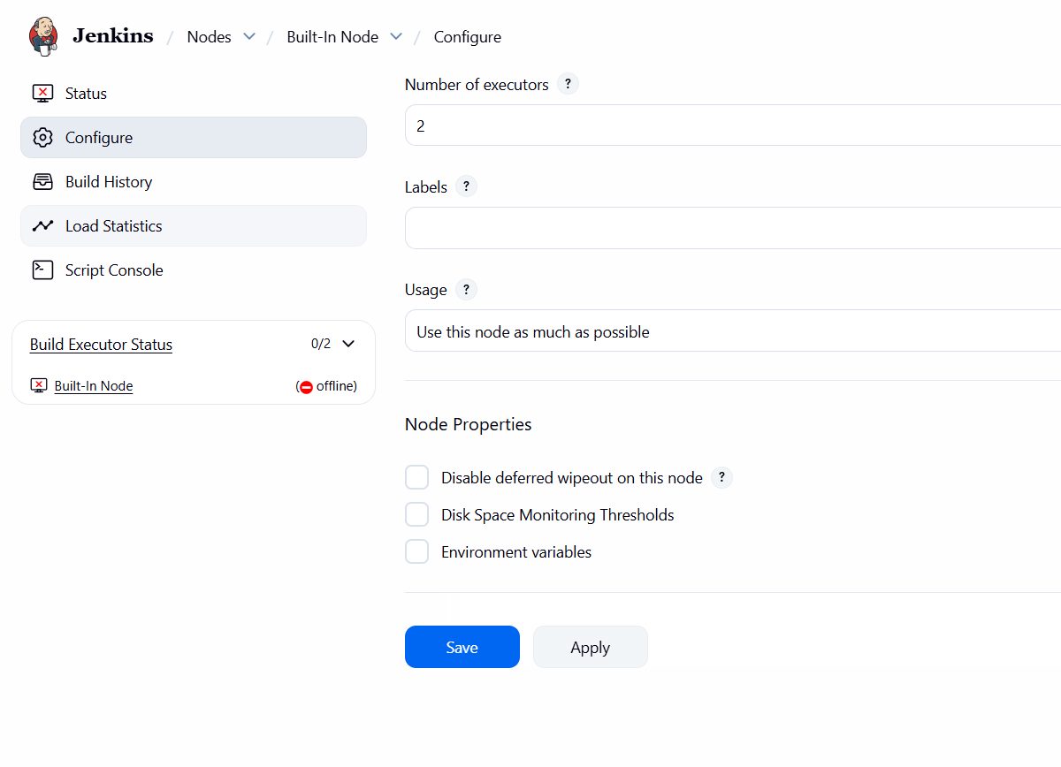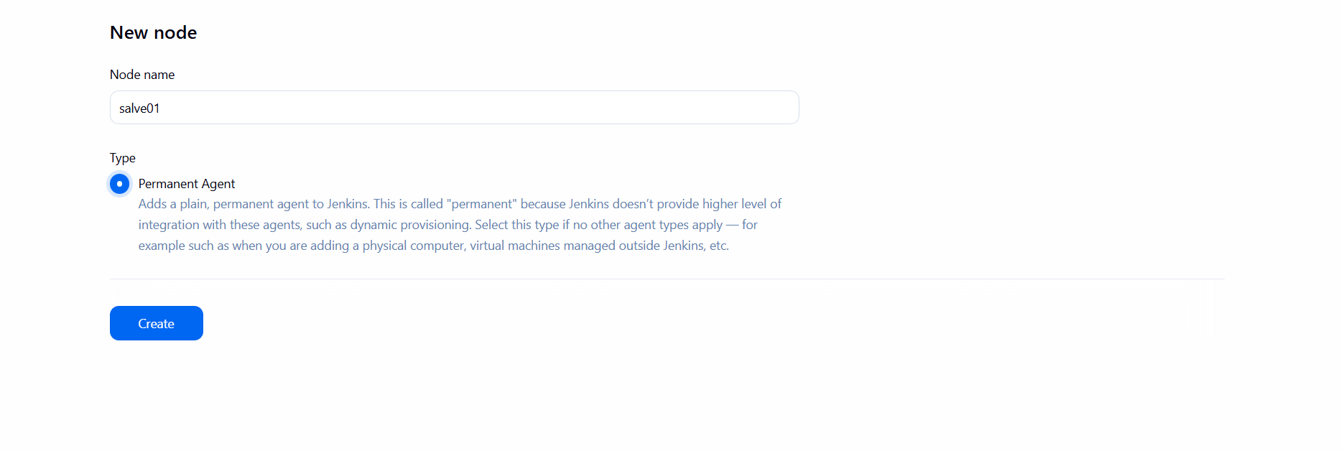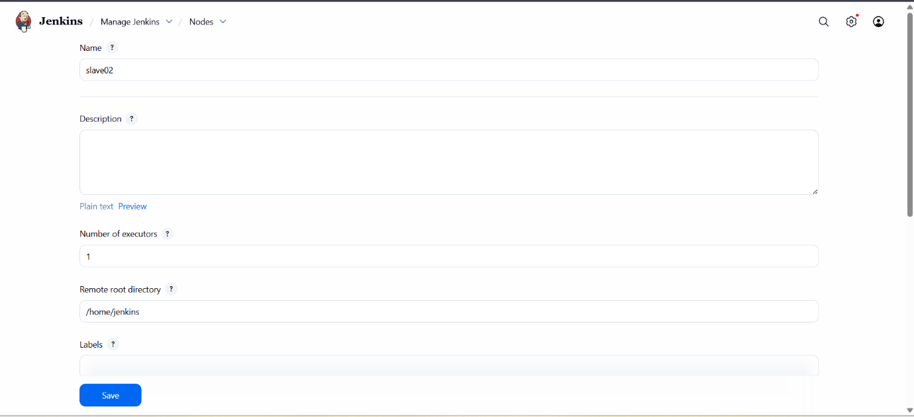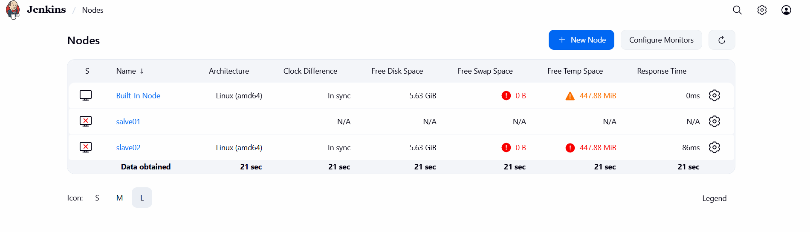

Configure webhooks to Jenkins job.
1. Enable GitHub/GitLab Integration Plugin
- Go to Manage Jenkins > Plugins.
- Install:
  - GitHub Integration Plugin (for GitHub)
  - GitLab Plugin (for GitLab)
2. Create or Open Jenkins Job
- Go to Jenkins Dashboard > New Item or open an existing job.
- Choose Freestyle project or Pipeline, depending on your setup.
3. Configure Source Code Management
- Under Source Code Management, select Git.
- Enter your repository URL.
- Add credentials if needed.
4. Enable Build Trigger via Webhook
- Scroll to Build Triggers.
- Check:
  - GitHub hook trigger for GITScm polling (for GitHub)
  - Build when a change is pushed to GitLab (for GitLab)
5. Configure Webhook in GitHub
- Go to your GitHub repo → Settings > Webhooks.
- Click Add webhook:
  - Payload URL: http://<jenkins-server>/github-webhook/
  - Content type: application/json
  - Events: Choose “Just the push event” or others as needed.
  - Save.
6. Configure Webhook in GitLab
- Go to your GitLab repo → Settings > Webhooks.
- Add:
  - URL: http://<jenkins-server>/project/<job-name>
  - Choose events like Push, Merge Request, etc.
  - Save.
7. Test the Webhook
- Make a commit or push to the repo.
- Jenkins should automatically trigger the job.

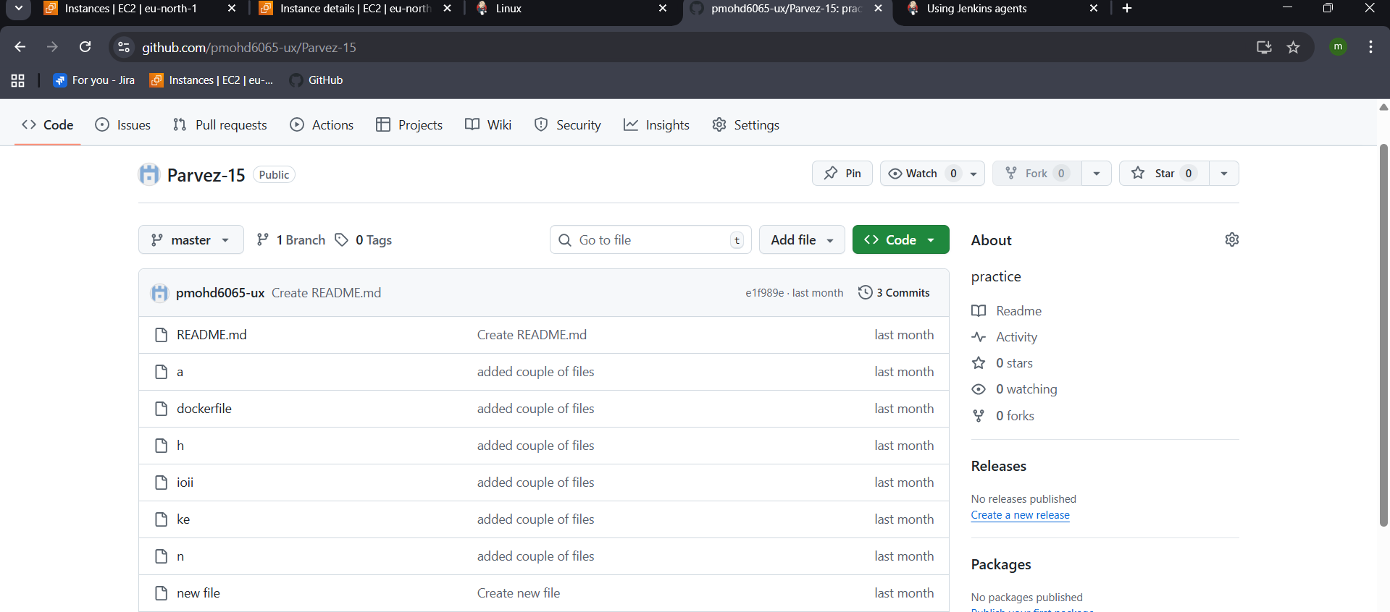
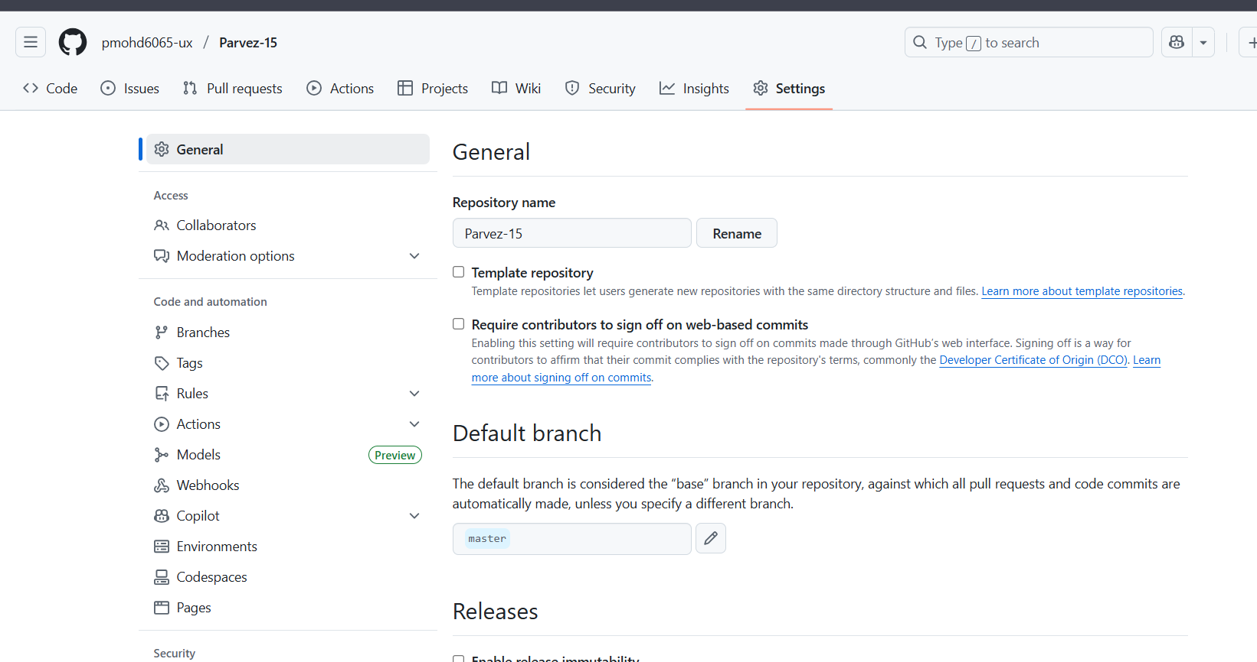
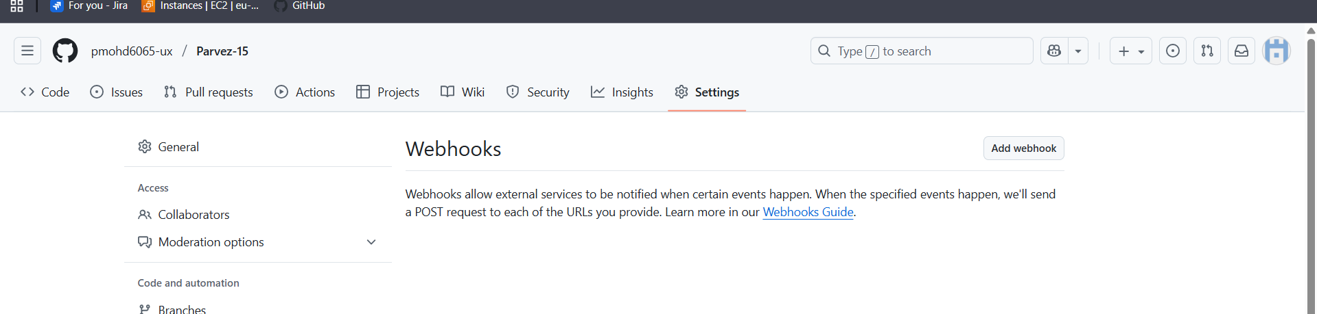
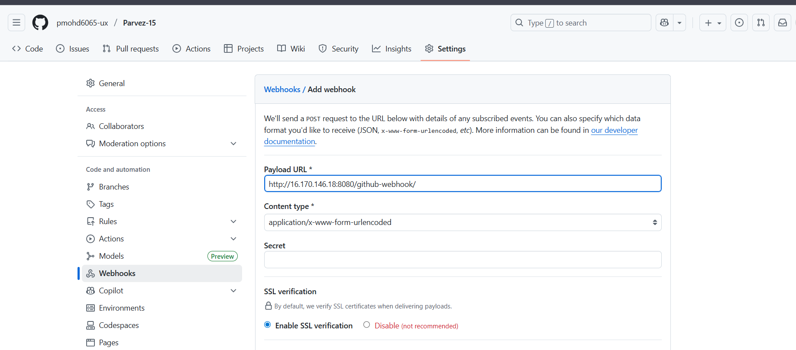
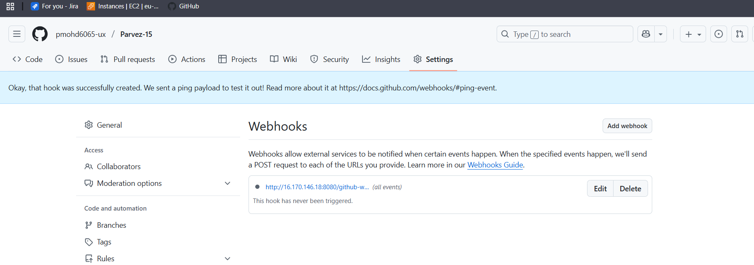

Configure poll scm and build periodical options in Jenkins job.
1. Configure Poll SCM
This checks the repository for changes at regular intervals.
Steps:
- Go to your Jenkins job → Configure.
- Scroll to Build Triggers.
- Check Poll SCM.
- In the Schedule field, enter a cron expression. Example:
- H/15 * * * *
This means: poll every 15 minutes (the H spreads load across nodes).
Notes:
- Jenkins polls the repo but only triggers a build if changes are detected.
- Cron format: MINUTE HOUR DOM MONTH DOW
  - H/15 * * * * → every 15 minutes
  - H 2 * * 1-5 → once at 2 AM on weekdays

2. Configure Build Periodically
This triggers builds at fixed intervals regardless of changes.
Steps:
- In the same Build Triggers section, check Build periodically.
- Enter a cron expression. Example:
- H 4 * * *
This means: build once daily at 4 AM.
Notes:
- Useful for scheduled tasks like nightly builds, backups, or reports.
- Does not check for SCM changes—runs unconditionally.
Example Use Case
If you want Jenkins to:
- Check for code changes every 15 minutes
- Run a full build every night at 2 AM
Use:
- Poll SCM: H/15 * * * *
- Build periodically: H 2 * * *

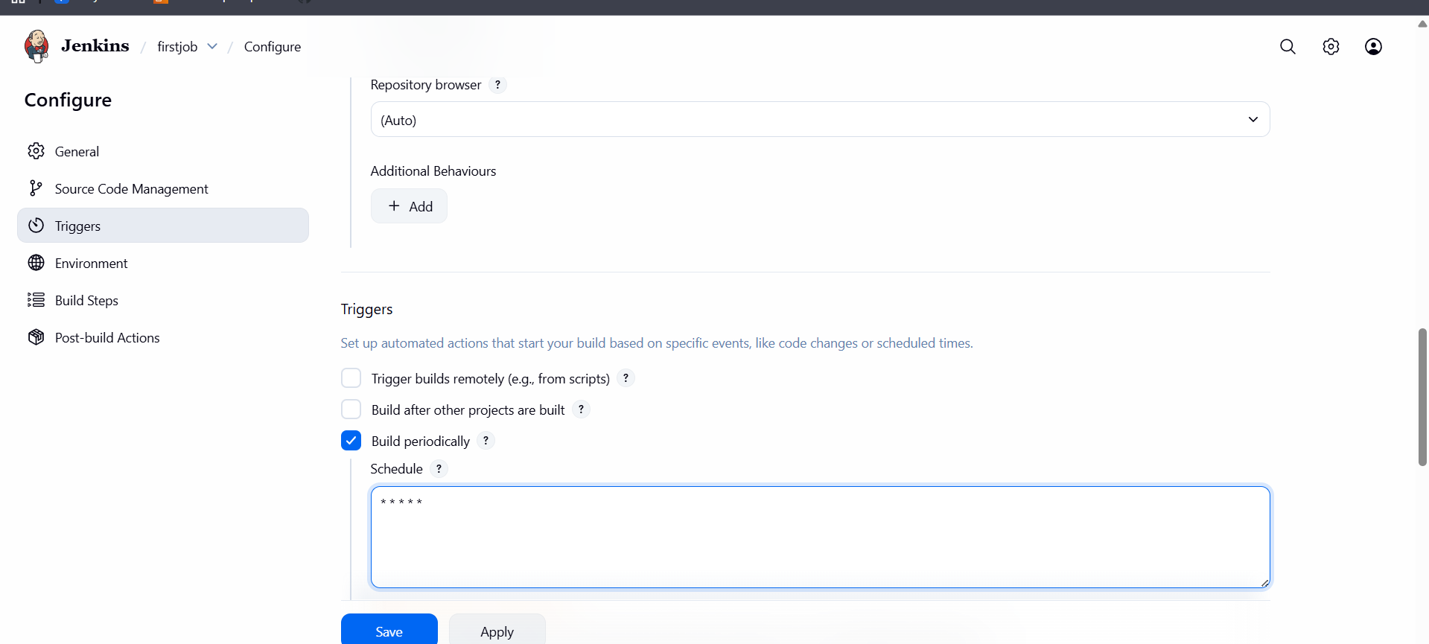

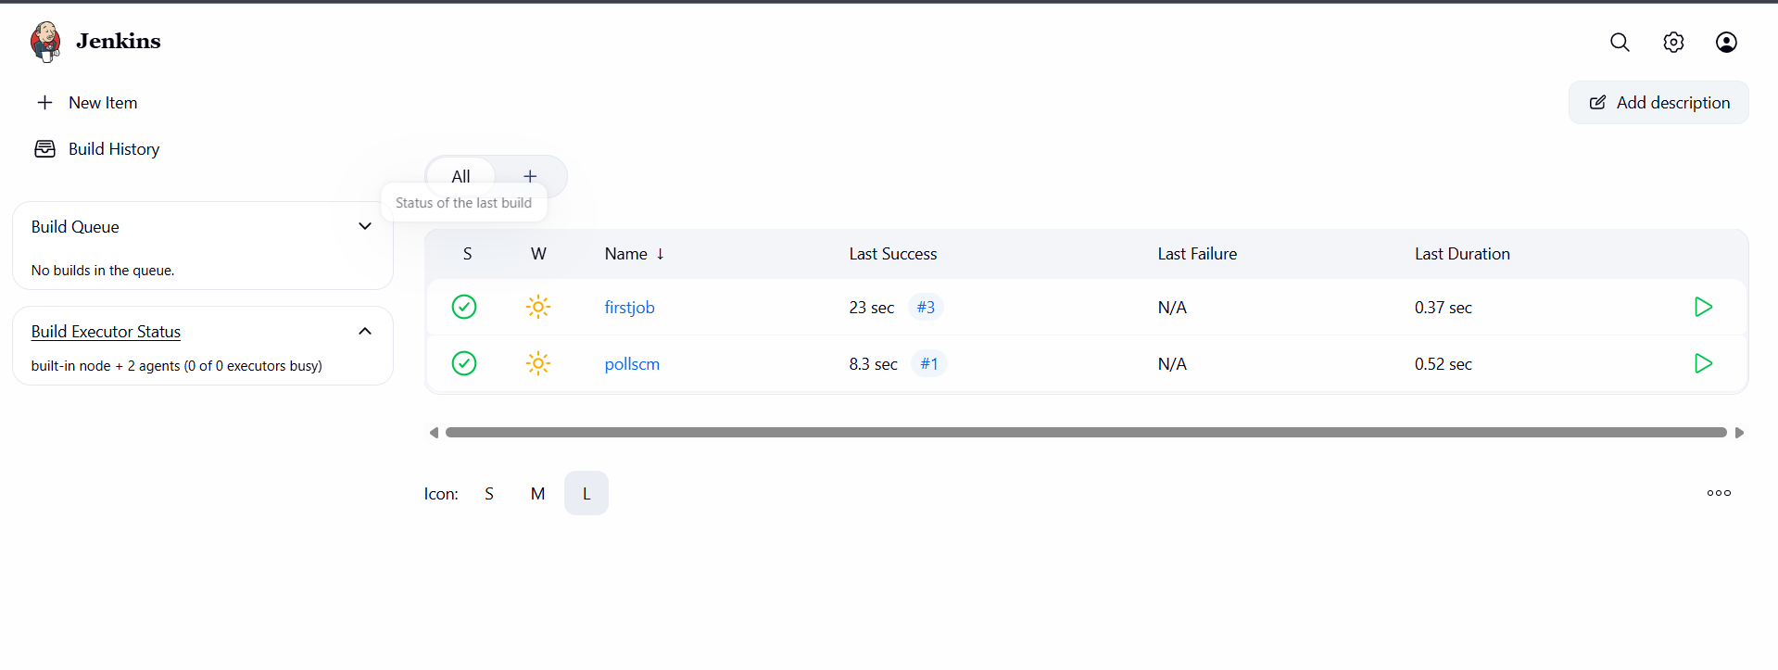

Take backup of Jenkins server by using bash script.
- Script to take backup
#!/bin/bash

# Variables
JENKINS_HOME="/var/lib/jenkins"
BACKUP_DIR="/backup/jenkins"
DATE=$(date +'%Y-%m-%d_%H-%M-%S')
BACKUP_FILE="$BACKUP_DIR/jenkins_backup_$DATE.tar.gz"

# Create backup directory if not exists
mkdir -p "$BACKUP_DIR"

# Stop Jenkins service (optional but safer)
echo "Stopping Jenkins service..."
systemctl stop jenkins

# Take backup
echo "Taking backup of Jenkins directory..."
tar -czvf "$BACKUP_FILE" "$JENKINS_HOME"

# Start Jenkins service back
echo "Starting Jenkins service..."
systemctl start jenkins

echo "Backup completed successfully!"
echo "Backup file stored at: $BACKUP_FILE"

- Write and save the script
- Give permissions : chmod +x Jenkins_backup.sh
- Run the script : ./ Jenkins_backup.sh
- Backup is taken
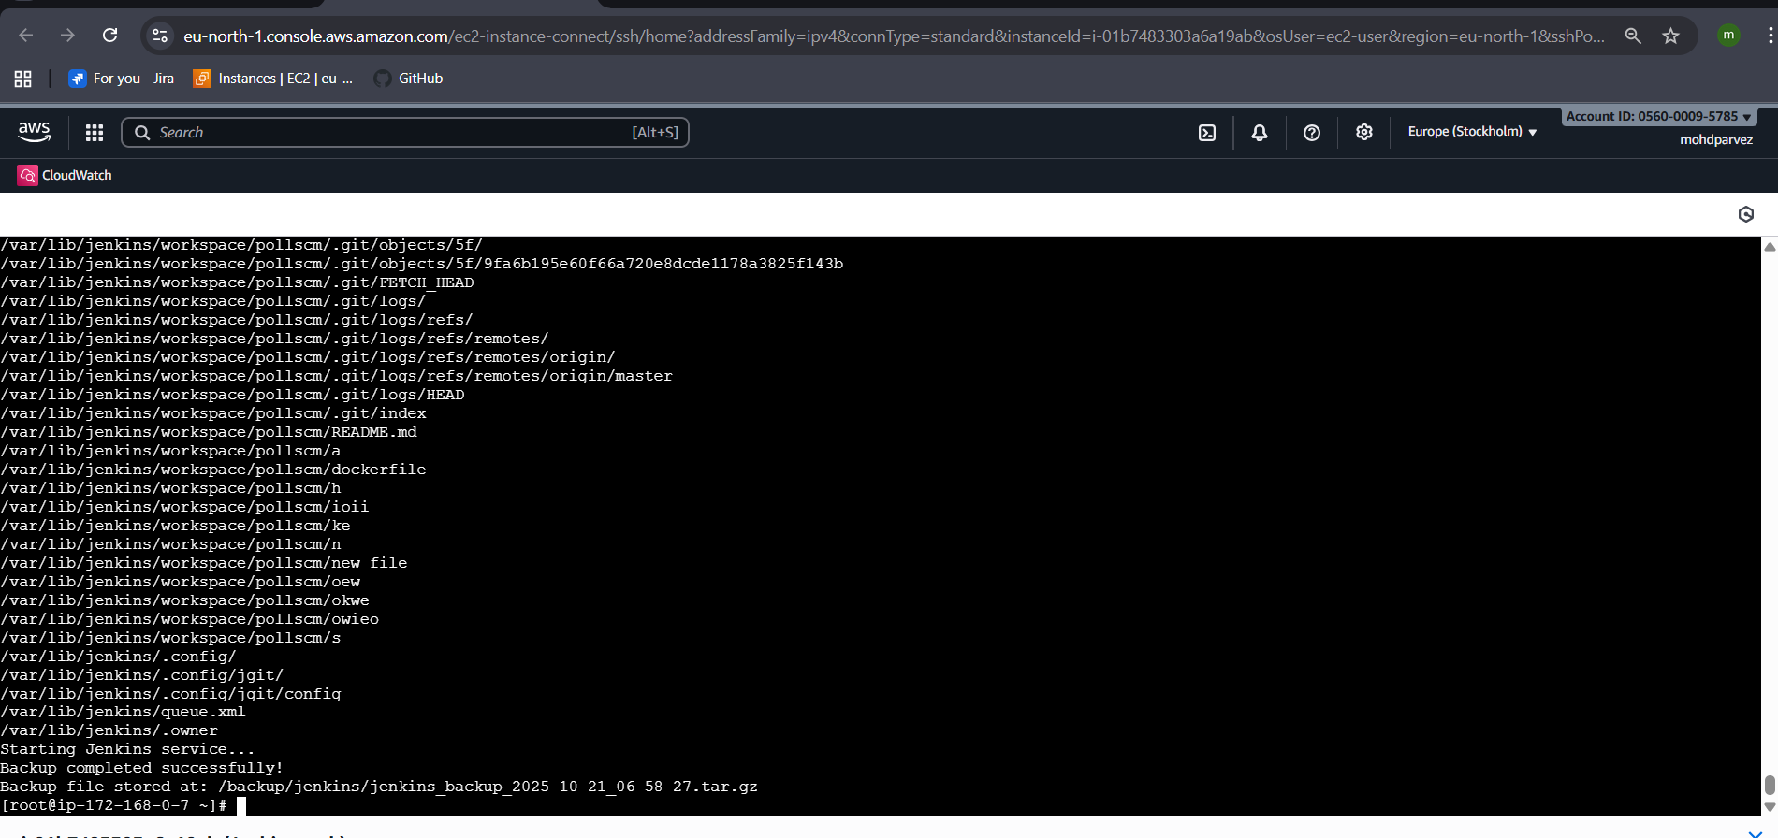

Take backup of Jenkins using thin backup plugin.
- Go to Jenkins manage Jenkinspluginssearch thininstall
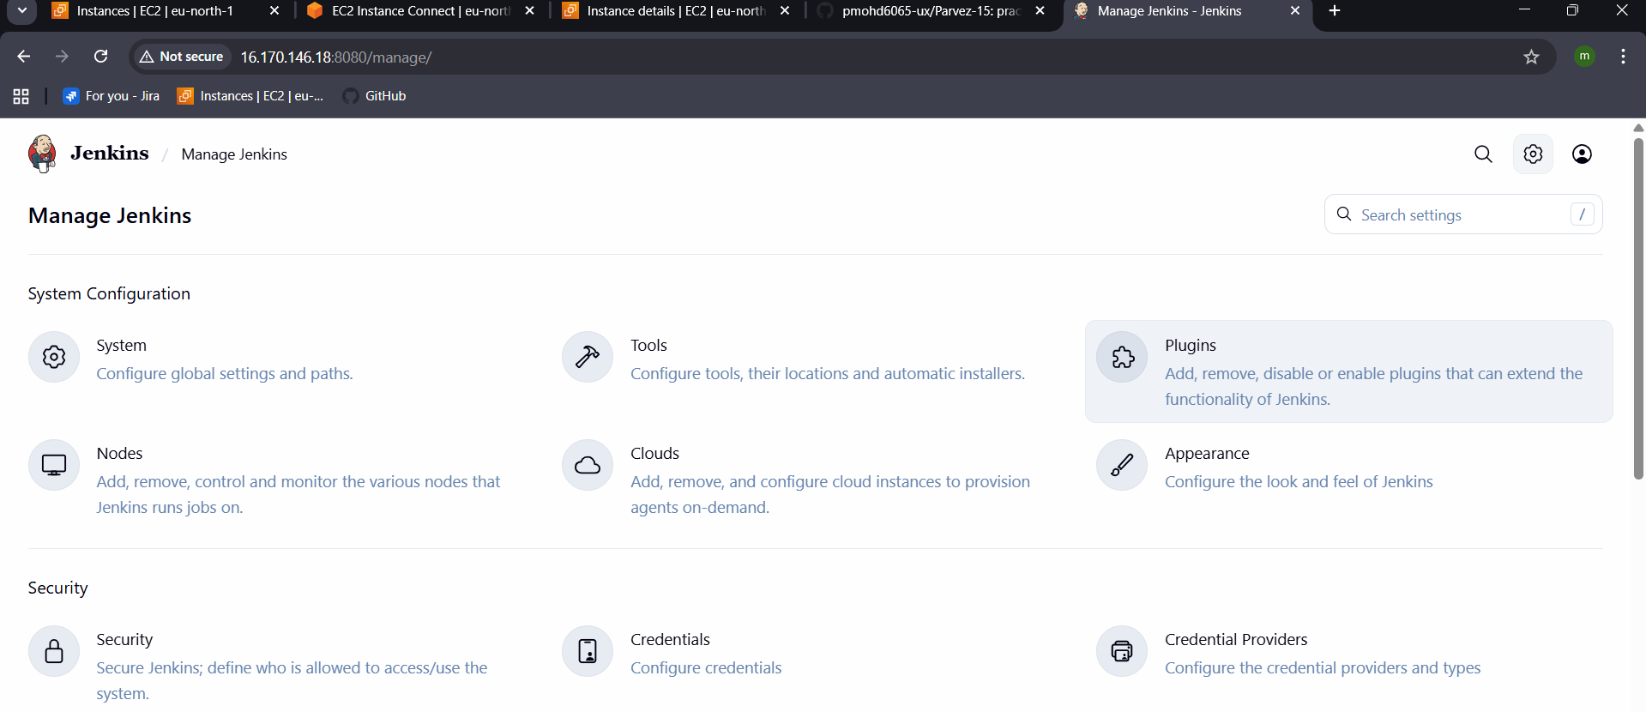
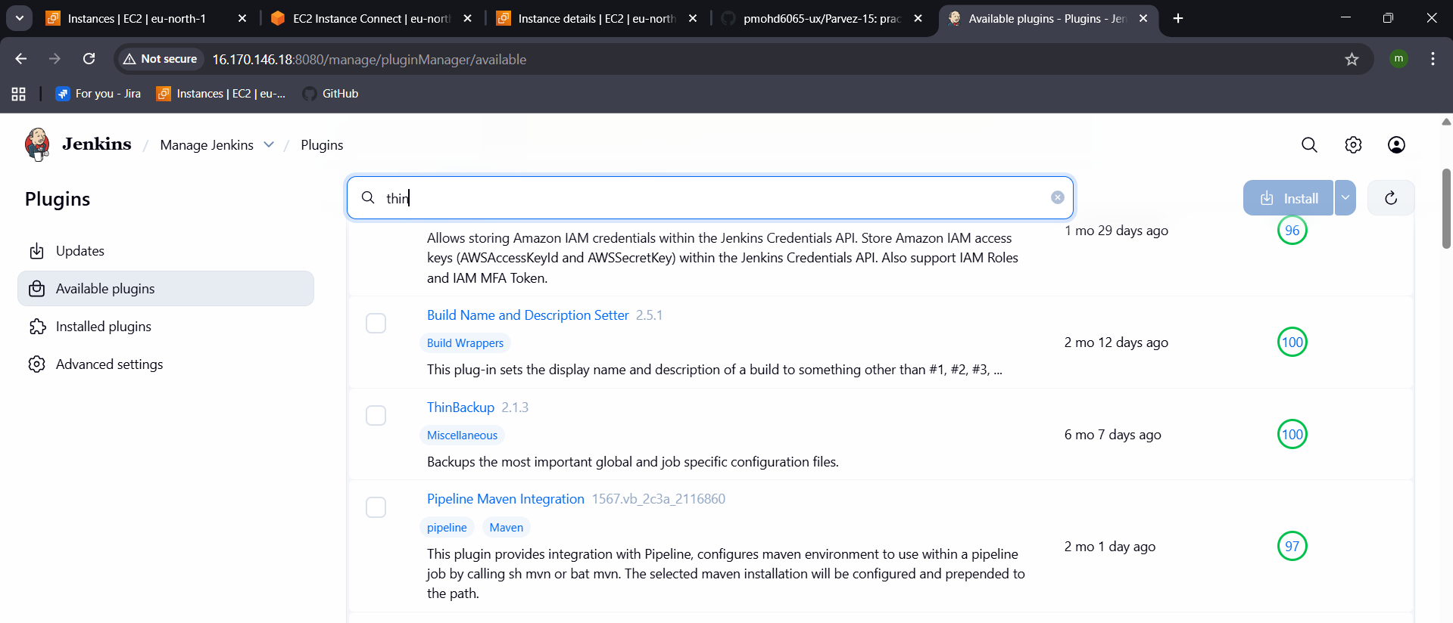
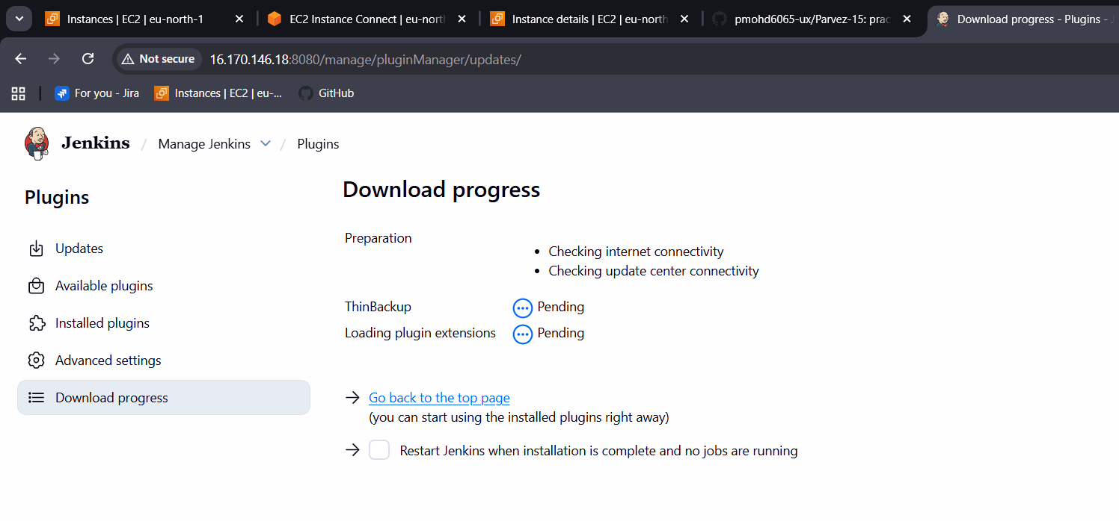

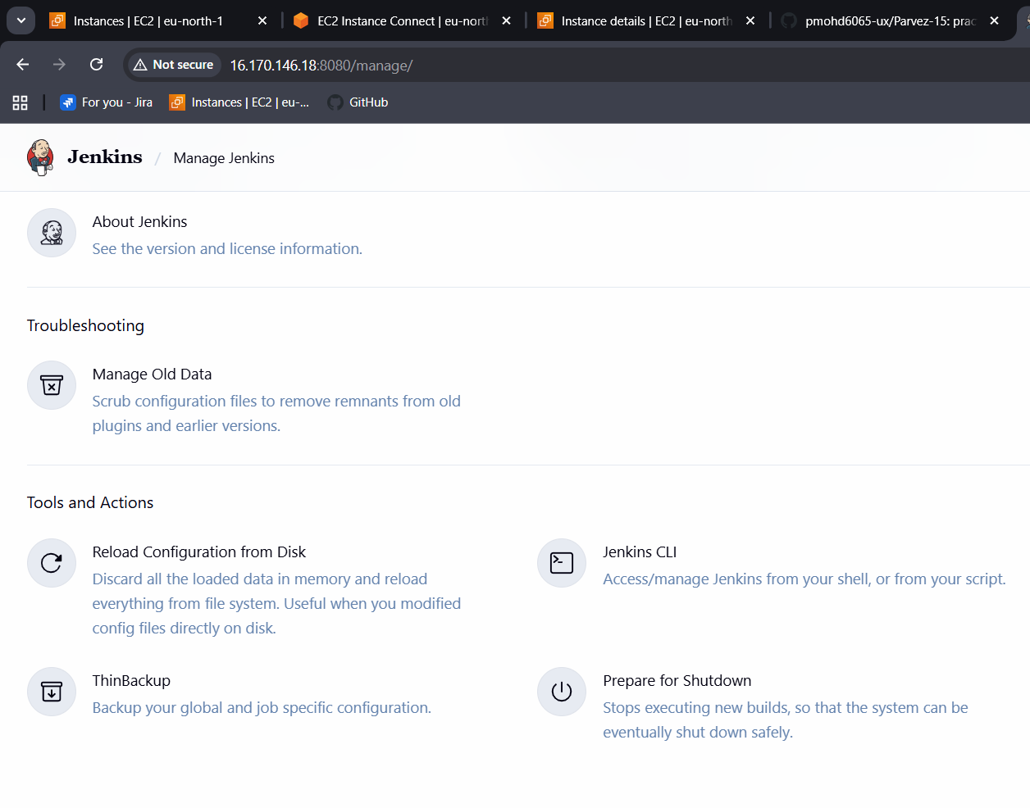
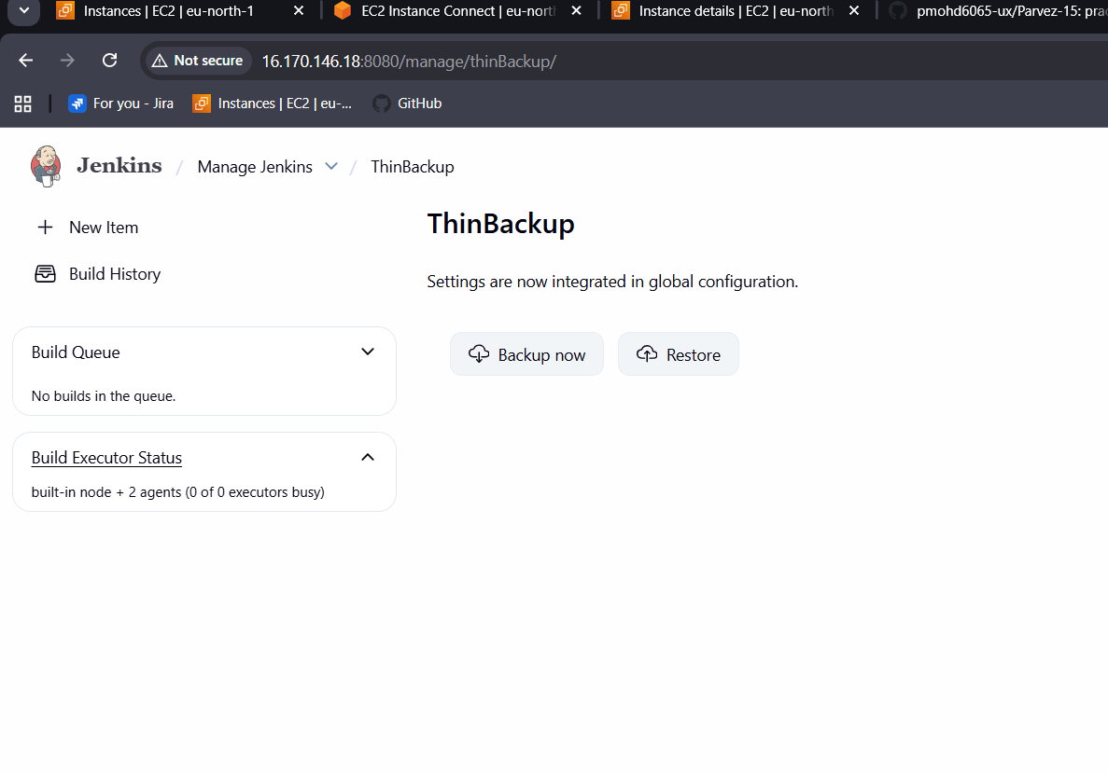

Setup a new Jenkins server and dump the backup taken in task4.

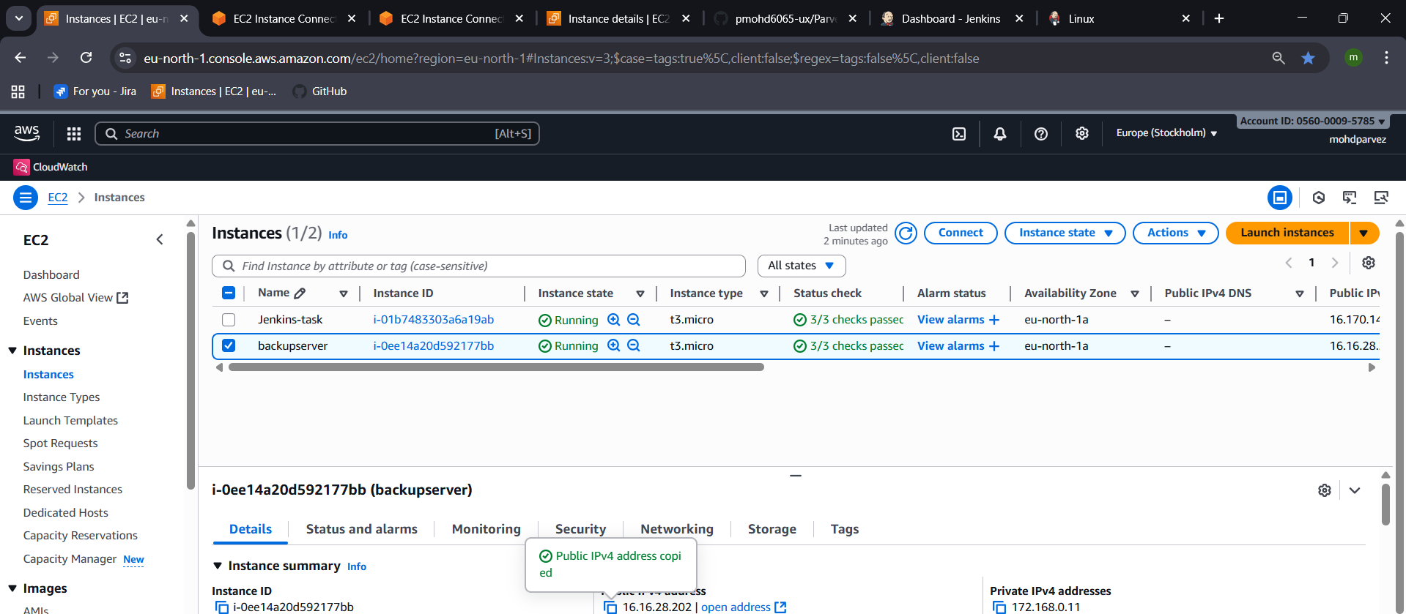
- Copy pem key and give permission
- Use command : scp -i test.pem /backup/jenkins/jenkins_backup_2025-10-21_06-58-27.tar.gz root@16.16.28.202:/tmp/
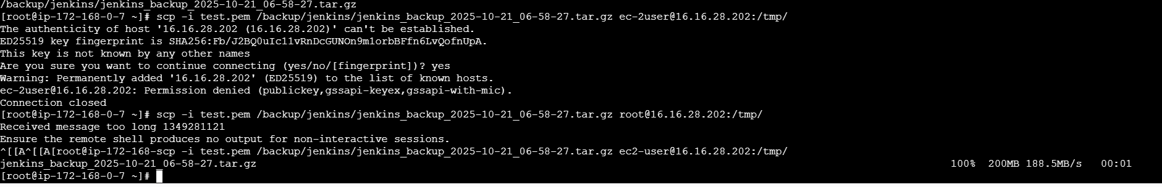
- Copy the file to /var/lib/
- Extract using tar -xvf
- Start the Jenkins service an login and check.
